Student’s name | …………………………………………………….…… | Grade | 4
Subject | Computer | Week No. | 11
Lesson Title | Scratch Extension | Unit | 4
Worksheet No. ( 10 )
Question A: Choose the correct option from option a-c.

1. Which block is added to stop drawing?
a. 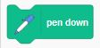 b. 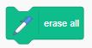 c. 
2. Which block is added at the beginning of the code for a clean stage when the code runs?
a.  b.  c. 
3. Which block is used to receive a broadcasted message by a sprite or backdrop?
a. 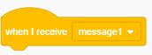 b.  c. 
4. A ___________ message can be received by any sprite.
a. Drawing b. Broadcasted c. Coloured
5. The __________ tool can be set to different sizes and colours.
a. Erase b. Events c. Pen

